

**MEMORANDUM OF UNDERSTANDING**

This is a document validating an agreement between **MR. OGABOR JOHN AND MR. KENDRICK LAMAR** for the collaborative of 20% interest over a sum of **ONE MILLION, TWO HUNDRED THOUSAND NAIRA ONLY (₦1,200,000) paid on the 29th of May, 2020.**

There is a binding agreement to pay the initial capital invested, alongside the interest, **ONE MILLION, FOUR HUNDRED AND FORTY THOUSAND NAIRA ONLY (₦1,440,000) on the 29th of June, 2020** by **MR. OGABOR JOHN TO MR. KENDRICK LAMAR.**

Attached with this document is an evidence of payment by **MR. KENDRICK LAMAR.**

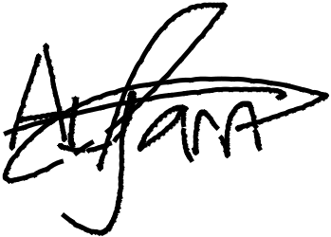

_________________________

_~~__~~_____~~___~~_~~_~~___________



**MR. KENDRICK LAMAR**

**MR. OGABOR JOHN**

***(CEO, JOHN INVESTMENTS)***